Exercises: PostgreSQL Table Relations

Submit your solutions to the SoftUni Judge Contest.
Ask your questions here: https://www.slido.com by entering the course code #python-db
For the upcoming assignments, let us direct our attention toward the implementation of the PRIMARY KEY.

PRIMARY KEY

a. Create a table
Create a new table called "products" that includes a column named "product_name" which has a maximum character limit of 100.
Insert the following values into the "products" table: 'Broccoli', 'Shampoo', 'Toothpaste', and 'Candy'.

Example
product_name
character varying (100)
Broccoli
Shampoo
Toothpaste
Candy

b. Define the primary key when changing the existing table structure
The newly created table does not have a unique identifier. To add a PRIMARY KEY, use the ALTER TABLE statement.
Submit your queries for the two-step task in the Judge system.

Example
product_name  character varying (100) | id  [PK] integer
Broccoli | 1
Shampoo | 2
Toothpaste | 3
Candy | 4

Remove Primary Key
Write an SQL statement to DROP CONSTRAINT from the "products" table.
*** Note, if a name is not specified explicitly for the primary key constraint, PostgreSQL will assign a default name to it. The default name for the primary key constraint is "table-name_pkey".
Submit your query for this task in the Judge system.

Example
product_name  character varying (100) | id  integer
Broccoli | 1
Shampoo | 2
Toothpaste | 3
Candy | 4

Let's redirect our attention to the One-To-One Relationship for the tasks ahead.

- Customs
To fulfill this assignment, you are required to establish a new database named "customs_db" and produce two tables inside it, named "passports" and "people".

a. Create and Insert Passports Table
Wright a SQL statement to create a new table called "passports" with two columns, "id" and "nationality". The "id" column should be an automatically incremented primary key, starting at 100 and incrementing by 1. The "nationality" column should have a maximum character limit of 50.
Then, insert three rows into the "passports" table with values 'N34FG21B', 'K65LO4R7', and 'ZE657QP2' for the "nationality" column.
*** Note, when using the GENERATED AS IDENTITY constraint, a SEQUENCE object is utilized, which allows for the specification of sequence options for system-generated values. The following syntax can be used to specify these options: (START WITH start_from_number INCREMENT BY increment_value).

Example
id | nationality
100 | N34FG21B
101 | K65LO4R7
102 | ZE657QP2

b. Create and Insert People Table
In the next step of this task, your objective is to create a new table called "people" which includes the following columns:
- "id" column that is an automatically incremented SERIAL PRIMARY KEY;
- "first_name" column with a maximum length of 50 characters and is of type VARCHAR;
- "salary" column which is specified to the second decimal place and has a maximum of 10 digits;
- "passport_id" column of type INT which is established as a FOREIGN KEY constraint and refers to the "id" column of the "passports" table.
After creating the "people" table, you need to insert three rows into it, each row should have values for the "first_name", "salary", and "passport_id" columns:
- ('Roberto', 43300.0000, 101)
- ('Tom', 56100.0000, 102)
- ('Yana', 60200.0000, 100)
Submit your queries for the two-step task in the Judge system.

Example
id | first_name | salary | passport_id
1 | Roberto | 43300.00 | 101
1 | Tom | 56100.00 | 102
2 | Yana | 60200.00 | 100

It is time to focus our attention on the One-To-Many/Many-To-One Relationship for the upcoming assignments.

4. Car Manufacture
To complete this task, you will need to create a database called "car_manufacture_db" that consists of three tables: "manufacturers", "models", and "production_years".

a. Create Tables
The "manufacturers" table should have a column, which is "name". In the "models" table, you should include columns for "model_name" and "manufacturer_id". The "production_years" table should contain information about "established_on" and "manufacturer_id". You are free to select the data type for each column, but it is crucial to ensure that each column has a unique identifier. Additionally, it is important to correctly set up the foreign keys. Note that the "models" identifier should start at 1000 and increment by 1.

b. Insert Data
Add data to the tables in the following manner:
manufacturers
name
BMW
Tesla
Lada
models
model_name | manufacturer_id
X1 | 1
i6 | 1
Model S | 2
Model X | 2
Model 3 | 2
Nova | 3

production_years
established_on | manufacturer_id
1916-03-01 | 1
2003-01-01 | 2
1966-05-01 | 3

Submit your queries for the two-step task in the Judge system.

5. Car Manufacture E/R Diagram**
Generate an Entity/Relationship Diagram for the three tables created in the Car Manufacture task.
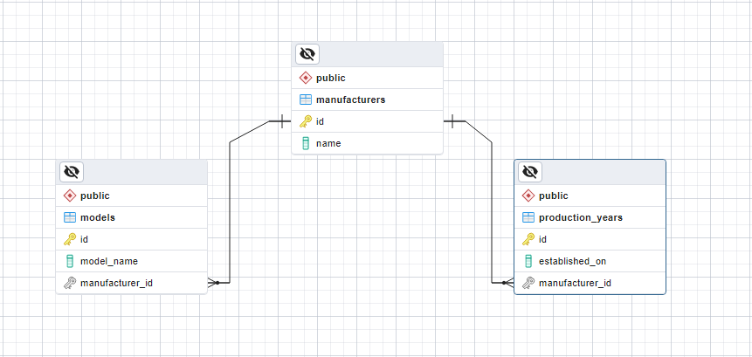

6. Photo Shooting
To finish this assignment, you need to create a database called "photo_shooting_db" that comprises two tables: "customers" and "photos".
The "customers" table should contain two columns - "name" and "date". In the "photos" table, you should include columns for "url" and "place". The data type for each column can be chosen according to your preference, but it is essential to ensure that each column has a unique identifier. Moreover, correctly setting up the foreign keys is crucial.
Insert data into the tables in the format shown below:
customers  name date  Bella 2022-03-25  Philip 2022-07-05 | photos  url place customer_id  bella_1111.com National Theatre 1  bella_1112.com Largo 1  bella_1113.com The View Restaurant 1  philip_1121.com Old Town 2  philip_1122.com Rowing Canal 2  philip_1123.com Roman Theater 2
Submit your query for this task in the Judge system.

7. Photo Shooting E/R Diagram**
Create an Entity/Relationship Diagram for the "customers" and "photos" tables created in the previous task.
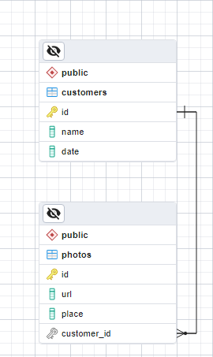

Let's focus on the Many-To-Many Relationship for the upcoming assignments.

8. Study Session [Solve with AI]
To complete this task, create a database named "study_session_db" that includes the following tables: "students", "exams", "study_halls", and "students_exams".
The "students" table should have a column for "student_name". In the "exams" table, include a column for "exam_name". The "study_halls" table should contain columns for "study_hall_name" and "exam_id". The "students_exams" table should have columns for "student_id" and "exam_id". You are free to choose the appropriate data type for each column but ensure each has a unique identifier. Note that the "exams" identifier should start at 101 and increment by 1. It is important to correctly set up the foreign keys.
Insert data into the tables in the format shown below:

students  student_name  Mila  Toni  Ron  students_exams  student_id exam_id  1 101  1 102  2 101  3 103  2 102  2 103 | exams  exam_name  Python Advanced  Python OOP  PostgreSQL | study_halls  study_hall_name exam_id  Open Source Hall 102  Inspiration Hall 101  Creative Hall 103  Masterclass Hall 103  Information Security Hall 103

Submit your query for this task in the Judge system.

9. Study Session E/R Diagram**
Create an Entity/Relationship Diagram for the "study_session_db" database, which includes four tables: "students", "exams", "study_halls", and "students_exams".
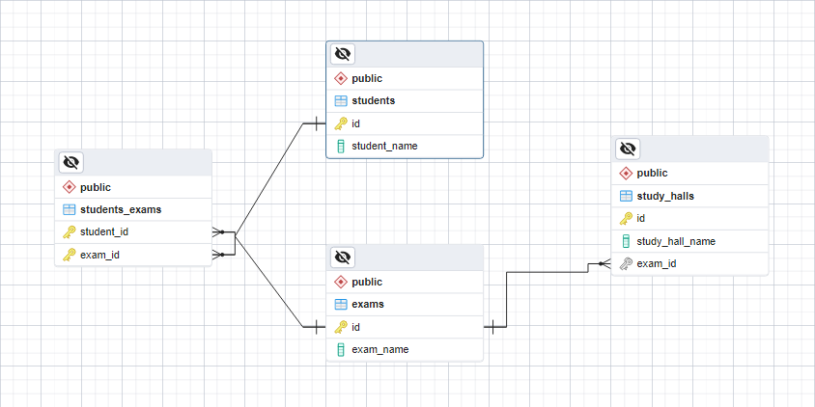

10. Online Store [Solve with AI]
Create a database called "online_store_db" using the provided E/R Diagram. Set up the necessary tables and ensure that their relationships are properly defined.
Important: When creating your tables, arrange the columns and foreign key constraints as shown in the diagram below.
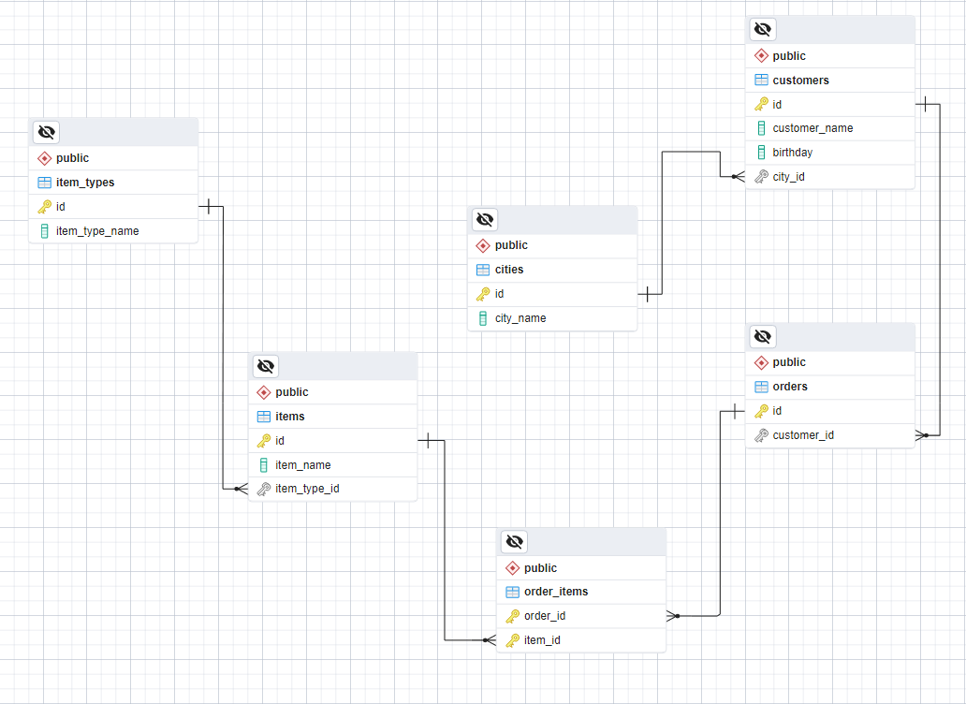
Submit your query for this task in the Judge system.
For the upcoming tasks, let's pay more attention to FOREIGN KEY and its Cascade Operations and ensure that they are correctly implemented. We will be using a database that you are already familiar with, but for the purpose of these tasks, the data has been modified. Therefore, create a new database named table_relations_geography_db. Download the 05-Exercises-Table-Relations-geography_db.sql file from the course instance, import it into your database's query tab, and execute the queries provided in the file.

11. Delete Cascade
Let's proceed to establish the relationships and update the "countries" table. Locate the columns that correspond to the "continents" and "currencies" tables, and ensure that when a record in the parent table is deleted, corresponding records in the child table are also deleted.
Submit your query for this task in the Judge system.

12. Update Cascade
Revise the "countries_rivers" table by ensuring that its relationship with the "rivers" and "countries" tables is properly updated. When a row in the parent tables is updated, ensure that matching rows in the child table are also updated.
Submit your query for this task in the Judge system.

13. SET NULL [Solve with AI]
Write SQL queries to create two new tables: "customers" and "contacts". The "customers" table should have a column for "customer_name", and the "contacts" table should contain columns for "contact_name", "phone", "email", and "customer_id". You can choose the data type for each column based on your preference, but it's important to ensure that each table has a unique identifier.
To set up the foreign keys correctly, make sure that when a record in the "customers" table is deleted, the corresponding records in the "contacts" table have their "customer_id" value set to NULL. Additionally, when a row in the "customers" table is updated, ensure that matching rows in the "contacts" table are also updated accordingly.
Insert data into the tables in the format shown below:
customers
customer_name
BlueBird Inc
Dolphin LLC
contacts
contact_name |  | phone | email | customer_id
John Doe |  | (408)-111-1234 | john.doe@bluebird.dev | 1
Jane Doe |  | (408)-111-1235 | jane.doe@bluebird.dev | 1
David Wright |  | (408)-222-1234 | david.wright@dolphin.dev | 2

Finally, remove the row from the "customers" table where the value of the "id" column matches 1.
Submit your query for this task in the Judge system.

Example
customers
id | customer_name
2 | Dolphin LLC
contacts
id | contact_name | phone |  | email | customer_id
1 | John Doe | (408)-111-1234 |  | john.doe@bluebird.dev | [null]
2 | Jane Doe | (408)-111-1235 |  | jane.doe@bluebird.dev | [null]
3 | David Wright | (408)-222-1234 |  | david.wright@dolphin.dev | 2

14. * Peaks in Rila [Solve with AI]
Retrieve data from the " table_relations_geography_db" database by joining the "mountains" and "peaks" tables using their common data. Then, display all peaks for the "Rila" mountain, including the "mountain_range", "peak_name", and "elevation". Finally, sort the results in descending order by the "elevation".
Submit your query for this task in the Judge system.

Example
mountain_range | peak_name | elevation
Rila | Musala | 2925
Rila | Malka Musala | 2902
Rila | Malyovitsa | 2729
Rila | Orlovets | 2685

15. * Countries Without Any Rivers [Solve with AI]
Create an SQL query that retrieves data from the "table_relations_geography_db" database by joining the "countries" and "countries_rivers" tables based on their common data. Then, calculate the total number of countries that do not have any rivers.
*** Note, using a LEFT JOIN will ensure that all records from the "countries" table are included in the result set, and a WHERE clause will filter out rows where the "countries_rivers" table has no corresponding records.
Submit your query for this task in the Judge system.

Example
countries_without_rivers
184

** This task is not required to be submitted to the Judge system and will not be considered in the final result.

